Our purpose is to create an international quarterly database for the Euro area that could be updated automatically. We want to build the following series:

Foreign demand (without trade between Euro area countries) Foreign interest rate

Oil prices

Real effective exchange rate Import and export

To construct these series we use data from DBnomics. The DBnomics API is called using the rdbnomics package.

# Foreign demand

We want to build a series that describes the evolution of the foreign demand for the Eurozone, without trade between Euro area countries. We proceed in three steps:

we calculate the growth of imports in volume of main trading partners;

we calculate the relative importance of each trading partner in Eurozone exports;

we sum over the growth rates of imports weighted by the relative importance of each trading partner.

## Imports of goods and services of Eurozone main commercial partners (volume, quarterly, seasonally adjusted)

First of all, we need to compute the variation of the demand originating from each trading partner of the Euro area. We select 14 trading partners that channel most of Eurozone’s exports.

### General case

Data comes from the OECD Economic Outlook database: we use imports of goods and services in volume.

partner_country_iso3 <- c('USA','GBR','DNK','NOR',' SWE','CAN','CHE','JPN','AUS','BRA','IND','IDN','KOR','CHN')

partner_country_name <- c('United-States','United-Kingdom','Denmark','Norway',' Sweden','Canada','Switzerland','Japan','Australia','Brazil', 'India','Indonesia','South Korea','China')

url_country_iso3 <- paste0(partner_country_iso3,collapse = "+") filter <- paste0(url_country_iso3,".P7.VOBARSA.Q")

df <- rdb("OECD","QNA",mask=filter)

imports <- df %>%

select(period,value,country=Country) %>% filter(year(period)>=1979) %>%

mutate(country = plyr::mapvalues(country, from = partner_country_iso3, to = partner_country_name))

ggplot(imports ,aes(period,value)) + geom_line(colour = blueObsMacro) + facet_wrap(~country, ncol = 3, scales = "free_y") + scale_x_date(expand = c(0.01,0.01)) +

theme + xlab(NULL) + ylab(NULL) +

ggtitle("Imports of goods and services",subtitle="(volume, seasonally adjusted, national currency)")



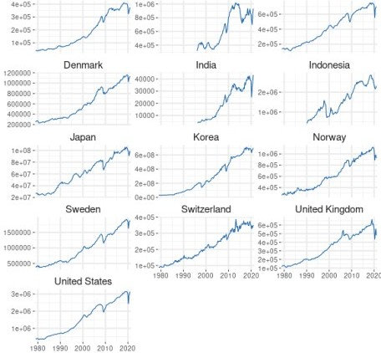

### China special case

Data series of imports of goods and services from China are not available in our dataset. We decide to take Chinese imports of goods and services from the WEO database (IMF). As it is annual, we use a spline interpolation to obtain a quarterly series.

df <- rdb(ids="IMF/WEO/CHN.TM_RPCH")

imports_cn <- df %>% select(period,

value) %>% na.omit() %>% arrange(period) %>%

mutate(value=100*cumprod(1+value/100)) %>% bind_rows(data.frame(period=as.Date("1997-01-01"),

value=100)) %>%

arrange(period)

imports_cn_q <- tibble(period=seq(min(imports_cn$period),

length.out=nrow(imports_cn)*4, by = "quarter")) %>%

left_join(imports_cn,by="period") %>% mutate(value=na.spline(value),

country="China")

### Growth rates

imports_growth_rate <- imports %>%

filter(country != "China") %>% bind_rows(imports_cn_q) %>% arrange(country,period) %>% group_by(country) %>% mutate(value=value/lag(value,1)-1) %>%

ungroup() %>% filter(year(period)>=1980)

ggplot(imports_growth_rate,aes(period,value)) + geom_line(colour = blueObsMacro) + facet_wrap(~country, ncol = 3, scales = "free_y") + scale_x_date(expand = c(0.01,0.01)) +

theme + xlab(NULL) + ylab(NULL) +

ggtitle("Growth rates of imports of goods and services", subtitle="(% quarter- on-quarter, volume, seasonally adjusted)")

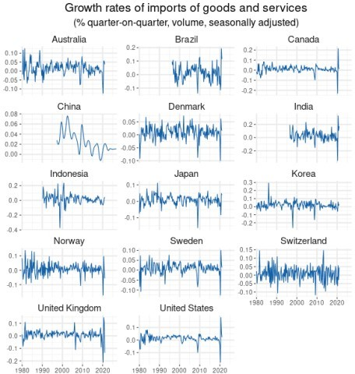

Mintime <- imports_growth_rate %>% group_by(country) %>%

summarize(MinTime = min(period)) %>% ungroup()

kable(Mintime)

|  |  |
| --- | --- |
| **country** | **MinTime** |
| Australia | 1980-01-01 |
| Brazil | 1996-01-01 |
| Canada | 1980-01-01 |
| China | 1997-01-01 |
| Denmark | 1980-01-01 |
| India | 1996-04-01 |
| Indonesia | 1990-01-01 |
| Japan | 1980-01-01 |
| Korea | 1980-01-01 |
| Norway | 1980-01-01 |
| Sweden | 1980-01-01 |

#### country MinTime

Switzerland 1980-01-01

United Kingdom 1980-01-01

United States 1980-01-01

We have uncomplete series only for Brazil, China, India and Indonesia.

## Eurozone’s exports of goods to main commercial partners (values US dollars, annual)

To compute the relative importance of each trading partner, we use data series of values of exports of goods (Free on board, in US dollars), from DOT database (IMF), for each Eurozone country towards extra-

area countries.

# Exporter countries of the Eurozone

ea_country <- c("AT","BE","R1","FR","DE","IT","LU","NL","FI","GR","IE"," MT ,"PT","ES","CY","SK","EE","LV","LT","SI")

ea_country_name <- c('Austria','Belgium','Luxembourg-Belgium','France',' Germany','Italy','Luxembourg','Netherlands','Finland',' Greece','Ireland','Malta','Portugal','Spain','Cyprus','Slovak Republic','Estonia','Latvia','Lithuania','Slovenia')

url_ea_country <- paste0(ea_country, collapse = "+")

# Importer countries outside the Eurozone

partner_country <- c("US","GB","DK","NO","SE","CA","CH","JP","AU","BR","IN"," ID","KR","CN")

url_partner_country <- paste0(partner_country, collapse = "+")

filter <- paste0('A.',url_ea_country,'.TXG_FOB_USD.', url_partner_country) df <- rdb("IMF","DOT",mask = filter)

bilatx <- df %>%

select(exporter = REF_AREA, importer = COUNTERPART_AREA, value,

period) %>%

mutate(exporter = plyr::mapvalues(exporter, from = ea_country, to = ea_country_name),

importer = plyr::mapvalues(importer, from = partner_country, to = partner_country_name)) %>%

filter(period >= '1979-01-01')

The following list shows, for each Eurozone country, the date from which we have data on exports towards each one of the 14 trading partners selected. We show the begining of the sample for each country.

start_sample <- bilatx %>%

group_by(exporter, importer) %>% summarize(MinTime = min(year(period))) %>% ungroup() %>%

spread(importer,MinTime)

start_sample[,1:8] %>% kable()

#### exporter Australia Brazil Canada China Denmark India Indonesia

Austria 1979 1979 1979 1979 1979 1979 1979

#### exporter Australia Brazil Canada China Denmark India Indonesia

|  |  |  |  |  |  |  |  |
| --- | --- | --- | --- | --- | --- | --- | --- |
| Belgium | 1997 | 1997 | 1997 | 1997 | 1997 | 1997 | 1997 |
| Cyprus | 1979 | 1982 | 1979 | 1980 | 1979 | 1979 | 1985 |
| Estonia | 1992 | 1993 | 1993 | 1992 | 1992 | 1993 | 1993 |
| Finland | 1979 | 1979 | 1979 | 1979 | 1979 | 1979 | 1979 |
| France | 1979 | 1979 | 1979 | 1979 | 1979 | 1979 | 1979 |
| Germany | 1979 | 1979 | 1979 | 1979 | 1979 | 1979 | 1979 |
| Greece | 1979 | 1979 | 1979 | 1979 | 1979 | 1979 | 1979 |
| Ireland | 1979 | 1979 | 1979 | 1979 | 1979 | 1979 | 1979 |
| Italy | 1979 | 1979 | 1979 | 1979 | 1979 | 1979 | 1979 |
| Latvia | 1992 | 1994 | 1993 | 1992 | 1992 | 1992 | 1993 |
| Lithuania | 1992 | 1994 | 1993 | 1992 | 1992 | 1993 | 1994 |
| Luxembourg | 1997 | 1997 | 1997 | 1997 | 1997 | 1997 | 1997 |
| Luxembourg-Belgium | 1979 | 1979 | 1979 | 1979 | 1979 | 1979 | 1979 |
| Malta | 1979 | 1979 | 1979 | 1979 | 1979 | 1979 | 1981 |
| Netherlands | 1979 | 1979 | 1979 | 1979 | 1979 | 1979 | 1979 |
| Portugal | 1979 | 1979 | 1979 | 1979 | 1979 | 1979 | 1979 |
| Slovak Republic | 1993 | 1993 | 1993 | 1993 | 1993 | 1993 | 1993 |
| Slovenia | 1993 | 1993 | 1993 | 1993 | 1993 | 1993 | 1993 |
| Spain | 1979 | 1979 | 1979 | 1979 | 1979 | 1979 | 1979 |

start_sample[,c(1,9:15)] %>% kable()

**exporter Japan Norway South Korea Sweden Switzerland United-Kingdom United-States**

|  |  |  |  |  |  |  |  |
| --- | --- | --- | --- | --- | --- | --- | --- |
| Austria | 1979 | 1979 | 1979 | 1979 | 1979 | 1979 | 1979 |
| Belgium | 1997 | 1997 | 1997 | 1997 | 1997 | 1997 | 1997 |
| Cyprus | 1979 | 1979 | 1980 | 1979 | 1979 | 1979 | 1979 |
| Estonia | 1992 | 1992 | 1993 | 1992 | 1992 | 1992 | 1992 |
| Finland | 1979 | 1979 | 1979 | 1979 | 1979 | 1979 | 1979 |
| France | 1979 | 1979 | 1979 | 1979 | 1979 | 1979 | 1979 |
| Germany | 1979 | 1979 | 1979 | 1979 | 1979 | 1979 | 1979 |
| Greece | 1979 | 1979 | 1979 | 1979 | 1979 | 1979 | 1979 |
| Ireland | 1979 | 1979 | 1979 | 1979 | 1979 | 1979 | 1979 |
| Italy | 1979 | 1979 | 1979 | 1979 | 1979 | 1979 | 1979 |
| Latvia | 1992 | 1992 | 1994 | 1992 | 1992 | 1992 | 1992 |
| Lithuania | 1992 | 1992 | 1993 | 1992 | 1992 | 1992 | 1992 |
| Luxembourg | 1997 | 1997 | 1997 | 1997 | 1997 | 1997 | 1997 |
| Luxembourg-Belgium | 1979 | 1979 | 1979 | 1979 | 1979 | 1979 | 1979 |
| Malta | 1979 | 1979 | 1979 | 1979 | 1979 | 1979 | 1979 |
| Netherlands | 1979 | 1979 | 1979 | 1979 | 1979 | 1979 | 1979 |
| Portugal | 1979 | 1979 | 1979 | 1979 | 1979 | 1979 | 1979 |
| Slovak Republic | 1993 | 1993 | 1993 | 1993 | 1993 | 1993 | 1993 |
| Slovenia | 1993 | 1993 | 1993 | 1993 | 1993 | 1993 | 1993 |
| Spain | 1979 | 1979 | 1979 | 1979 | 1979 | 1979 | 1979 |

**Special case of Belgium-Luxembourg**

We have data for Belgium-Luxembourg as a single exporter until 1997. So we compute extra-area trade of Belgium and Luxembourg since 1997 to create a series for the whole period.

bilatx.Belux <-

filter(bilatx, exporter %in% c('Belgium','Luxembourg')) %>% group_by(importer, period) %>%

summarize(value = sum(value)) %>% ungroup() %>%

mutate(exporter = "Luxembourg-Belgium")

bilatx %<>%

filter(!exporter %in% c('Belgium','Luxembourg')) %>% rbind(bilatx.Belux)

### Special case of Eastern European countries

Before 1992, five countries lack some data: the Baltic states, Slovenia and Slovak Republic. On the following graph, we represent the sum of exports of the Eurozone with and without these five countries.

export_15 <- bilatx %>%

filter(!exporter %in% c("Slovenia","Slovak Republic","Latvia","Estonia"," Lithuania")) %>%

mutate(var = 'Eurozone - 15') %>% group_by(var, period) %>% summarize(value = sum(value)) %>% ungroup()

export_all <- bilatx %>%

mutate(var = 'Eurozone - all') %>% group_by(var,period) %>% summarize(value = sum(value)) %>% ungroup()

plot_export <- rbind(export_15, export_all)

ggplot(plot_export,aes(period,value, colour = var)) + geom_line() +

scale_x_date(expand = c(0.01,0.01)) + theme + xlab(NULL) + ylab(NULL) + theme(legend.title=element_blank()) +

ggtitle("Extra-Eurozone exports, with / without Eastern countries")

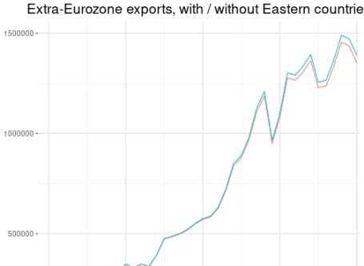

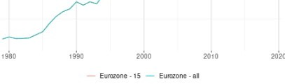

Before 2003, both series are very similar. So we choose to keep the whole dataset as it is.

### Special case of Brazil, China, India and Indonesia

We saw in the previous section that we have uncomplete series of imports of goods and services for Brazil, China, India and Indonesia, with a lack of data before 1997. As these specific countries developed their imports mainly after 1997, we want to check the growth rates of extra-area exports with and without these partners before 1997.

import_10 <- bilatx %>%

filter(!importer %in% c("Brazil","China","India","Indonesia")) %>% group_by(period) %>%

summarize(value=sum(value)) %>% ungroup() %>%

mutate(var= "Importers - 10")

plot_export2 <- bind_rows(mutate(export_all,var="Importers - all"),

import_10) %>% group_by(var) %>% mutate(value2=value/lag(value)-1) %>% filter(year(period)<=1997)

ggplot(plot_export2,aes(period,value2, colour = var)) + geom_line() +

scale_x_date(expand = c(0.01,0.01)) + theme + xlab(NULL) + ylab(NULL) + theme(legend.title=element_blank()) +

ggtitle("Growth rate of extra-area exports, with 10 and 14 partners")

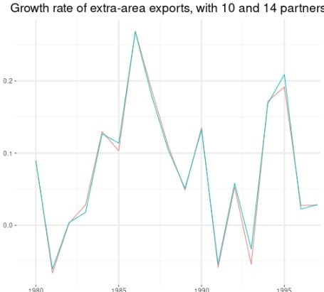



Before 1997, both series are very similar. So we choose to compute weights of 14 commercial partners after 1997 but of only 10 partner before 1997 (without Brazil, China, India and Indonesia).

### Weights of main commercial partners in Eurozone’s exports

For each commercial partner \(i\), we compute \(\alpha_i\), the share of EA exports \(X\) among all EA exports towards these partners, at time \(t\) :

$$ \alpha_{i,t} = \frac{ X_{i,t} }{ \sum_i X_{i,t} } $$

#Sum of exports of Euro area by importer bilatx %<>%

group_by(importer,period) %>% summarize(value = sum(value)) %>% ungroup()

#Sum of exports of Euro area to 14 importers sumX_EA_importer_all <-

bilatx %>% group_by(period) %>%

summarise(xsum = sum(value)) %>% mutate(exporter = 'Eurozone') %>% ungroup()

alphas_importer_all <-

left_join(sumX_EA_importer_all, bilatx, by = 'period') %>% mutate(alpha = value/xsum) %>% select(period,country=importer,alpha)

#Sum of exports of Euro area to 14 importers sumX_EA_importer_10 <-

bilatx %>%

filter(! importer %in% c("Brazil","China","India","Indonesia")) %>% group_by(period) %>%

summarise(xsum = sum(value)) %>% mutate(exporter = 'Eurozone') %>% ungroup()

alphas_importer_10 <- left_join(sumX_EA_importer_10,

filter(bilatx,! importer %in% c("Brazil","China","India"," Indonesia")),

by = 'period') %>% mutate(alpha = value/xsum) %>% select(period,country=importer,alpha)

alphas <- bind_rows(

filter(alphas_importer_10,year(period)<=1997), filter(alphas_importer_all,year(period)>1997)

)

ggplot(alphas,aes(period,alpha)) + geom_line(colour = blueObsMacro) +

facet_wrap(~country, ncol = 3, scales = "free_y") +

scale_x_date(expand = c(0.01,0.01)) + theme + xlab(NULL) + ylab(NULL) +

ggtitle("Share of Eurozone exports among all Eurozone exports")

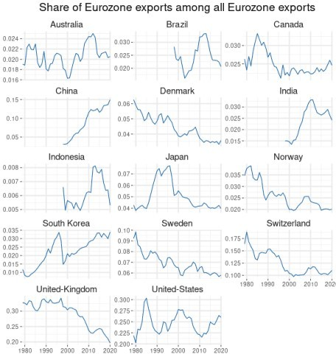

## Final index

We sum over the growth rates of imports in volume weighted by the relative importance of each trading partner during the previous year. Then we create a global index.

imports_growth_rate %<>% mutate(year=year(period)) alphas %<>% mutate(year=year(period)+1) %>%

select(-period)

wd <-

right_join(alphas, imports_growth_rate, by = c("year", "country")) %>% mutate(value = alpha * value) %>%

na.omit() %>% select(period,value,country) %>% group_by(period) %>% summarise(value = sum(value)) %>% mutate(value = cumprod(1+value))

wd_index2010 <- wd %>%

mutate(year = year(period)) %>% filter(year == "2010") %>% group_by(year) %>% summarize(value = mean(value)) %>% ungroup()

wd_index <- wd %>%

mutate(period,

value = 100*value/wd_index2010$value)

wd_index_growth <- wd_index %>%

mutate(value=value/lag(value,4)-1, var="2- Growth rate")

plot_wd <- bind_rows(wd_index_growth,

mutate(wd_index,var="1- Level"))

ggplot(plot_wd,aes(period,value)) + geom_line(colour = blueObsMacro) + facet_wrap(~var, scales = "free_y",ncol=1) + scale_x_date(expand = c(0.01,0.01)) +

theme + xlab(NULL) + ylab(NULL) +

ggtitle("Foreign demand for the Eurozone, base 100 = 2010")

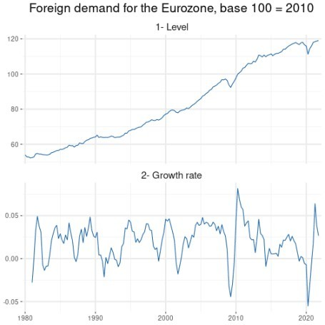

# Foreign interest rate

We use the US federal funds rate overnight as a proxy for the foreign interest rate.

df <- rdb(ids="FED/H15/129.FF.O")

shortrate <- df %>%

mutate(period=paste(year(period),quarter(period),sep="-")) %>% group_by(period) %>%

summarise(value=mean(value)) %>% ungroup() %>% mutate(period=yq(period)) %>% filter(period >= "1980-01-01")

ggplot(shortrate,aes(period,value)) +

geom_line(colour = blueObsMacro) + scale_x_date(expand = c(0.01,0.01)) + theme + xlab(NULL) + ylab(NULL) + ggtitle('Foreign interest rate')

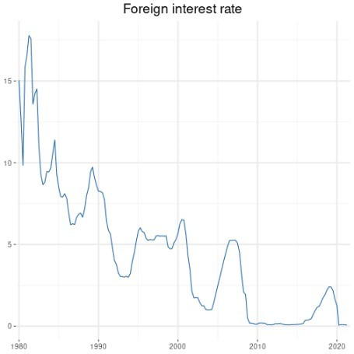

# Oil prices

We need to download a series that reflects oil prices to build a foreign block. We take the series from the OECD Economic Outlook database.

df <- rdb(ids = "OECD/EO/OTO.WPBRENT.Q")

oil_prices <- df %>%

select(period, value) %>% filter(period >= "1980-01-01")

ggplot(oil_prices,aes(period,value)) + geom_line(colour = blueObsMacro) + scale_x_date(expand = c(0.01,0.01)) + theme + xlab(NULL) + ylab(NULL) + ggtitle('Crude oil prices')

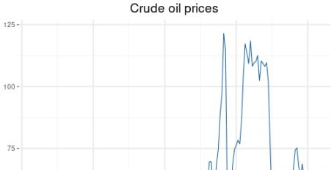

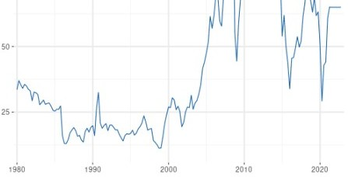

# Real effective exchange rate

df <- rdb(ids = "BIS/EERI/M.R.N.XM")

reer <- df %>%

mutate(period=paste(year(period),quarter(period),sep="-")) %>% group_by(period) %>%

summarize(value=mean(value)) %>% ungroup() %>% mutate(period=yq(period)) %>% filter(period >= "1980-01-01")

ggplot(reer,aes(period,value)) + geom_line(colour = blueObsMacro) + scale_x_date(expand = c(0.01,0.01)) + theme + xlab(NULL) + ylab(NULL) + ggtitle('Real Effective Exchange Rate')

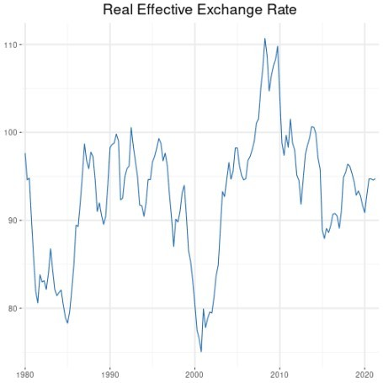

# Extra Euro area imports and exports

df <- rdb("ECB","TRD",mask = 'M.I8.Y.M+X.TTT.J8.4.VOX')

trade <- df %>%

transmute(period=paste(year(period),quarter(period),sep="-"), value,

var=ifelse(grepl("Import",series_name),"imports","exports")) %>% group_by(var,period) %>%

summarize(value = mean(value)) %>% ungroup() %>% mutate(period=yq(period))

ggplot(trade,aes(period,value)) + geom_line(colour = blueObsMacro) + facet_wrap(~var)+ scale_x_date(expand = c(0.01,0.01)) + theme + xlab(NULL) + ylab(NULL) +

ggtitle('Extra euro area imports / exports, in volume, seasonally adjusted')

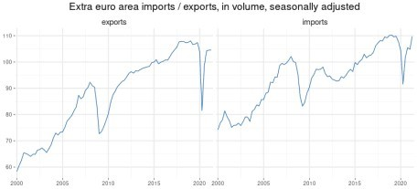

# Final international database for the Euro area

We eventually build an international database for the Euro area.

rawdata <- bind_rows(

mutate(wd_index, var = 'world_demand'), mutate(shortrate, var = 'foreign_rate'), mutate(oil_prices, var = 'oil_prices'), mutate(reer, var = "reer"),

trade)

We can check the last date available for each variable.

maxDat <- rawdata %>%

group_by(var) %>% summarize(maxdate=max(period)) %>% arrange(maxdate)

kable(maxDate)

|  |  |
| --- | --- |
| **var** | **maxdate** |
| exports | 2019-07-01 |
| imports | 2019-07-01 |
| foreign_rate | 2019-10-01 |
| reer | 2019-10-01 |

world_demand 2019-10-01

#### var maxdate

oil_prices 2021-10-01

minmaxDate <- min(maxDate$maxdate) EA_Open_rawdata <-

rawdata %>%

filter(period <= minmaxDate) %>% spread(var,value)

EA_Open_rawdata %>% write.csv("EA_Open_rawdata.csv", row.names=FALSE)

So we filter the database until 2019 Q3.

sw03 <- read.csv("<http://shiny.nomics.world/data/EA_SW_rawdata.csv>") %>% mutate(period=ymd(period))

EA_Open_data <- EA_Open_rawdata %>%

inner_join(sw03,by="period") %>% transmute(period,

world_demand, foreign_rate, oil_prices, reer, imports, exports)

EA_Open_data %>%

mutate(period=gsub(" ","",as.yearqtr(period))) %>% write.csv(file = "EA_Open_data.csv",row.names = FALSE)

# Appendix

## Chain

This function chain two series, using the growth rate of the historical one to deduce new points on the original series. It allows to go further back in time with one series while keeping the most recent points.

chain <- function(to_rebase, basis, date_chain) {

date_chain <- as.Date(date_chain, "%Y-%m-%d") valref <- basis %>%

filter(period == date_chain) %>% transmute(country, value_ref = value)

res <- to_rebase %>% filter(period <= date_chain) %>% arrange(desc(period)) %>% group_by(country) %>%

mutate(growth_rate = c(1, value[-1]/lag(value)[-1])) %>% full_join(valref, by = "country") %>%

group_by(country) %>%

transmute(period, value = cumprod(growth_rate)*value_ref)%>%

ungroup() %>%

bind_rows(filter(basis, period > date_chain)) %>% arrange(period)

return(res)

}